21BCM053

Ronit Bhattacharya

**Assignment-2**

**Web Technology**

Screenshots

1) Login Page

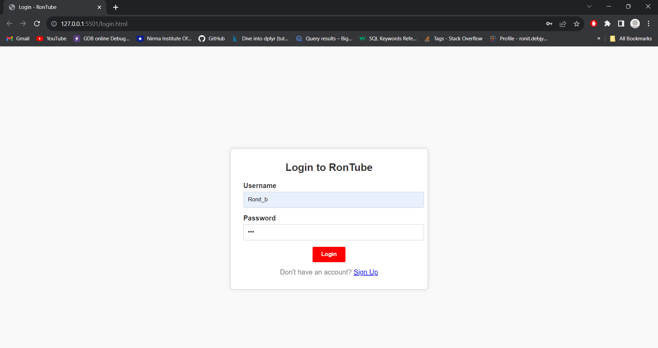

Login Unsuccessful

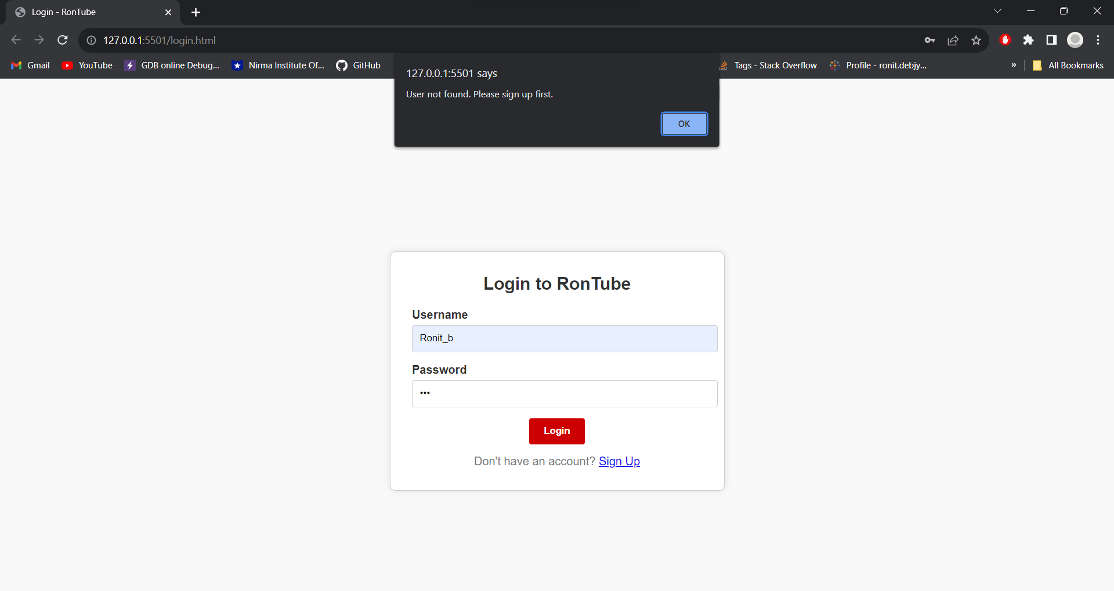

2) Sign-Up Page

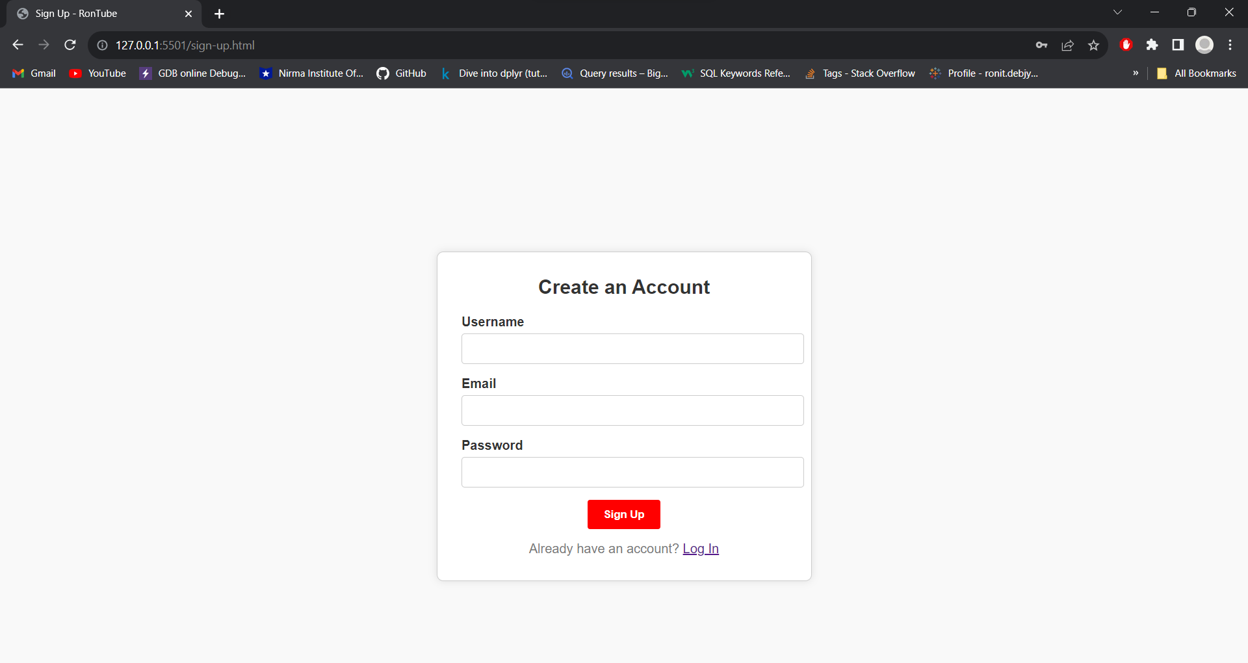

Sign-Up Successful

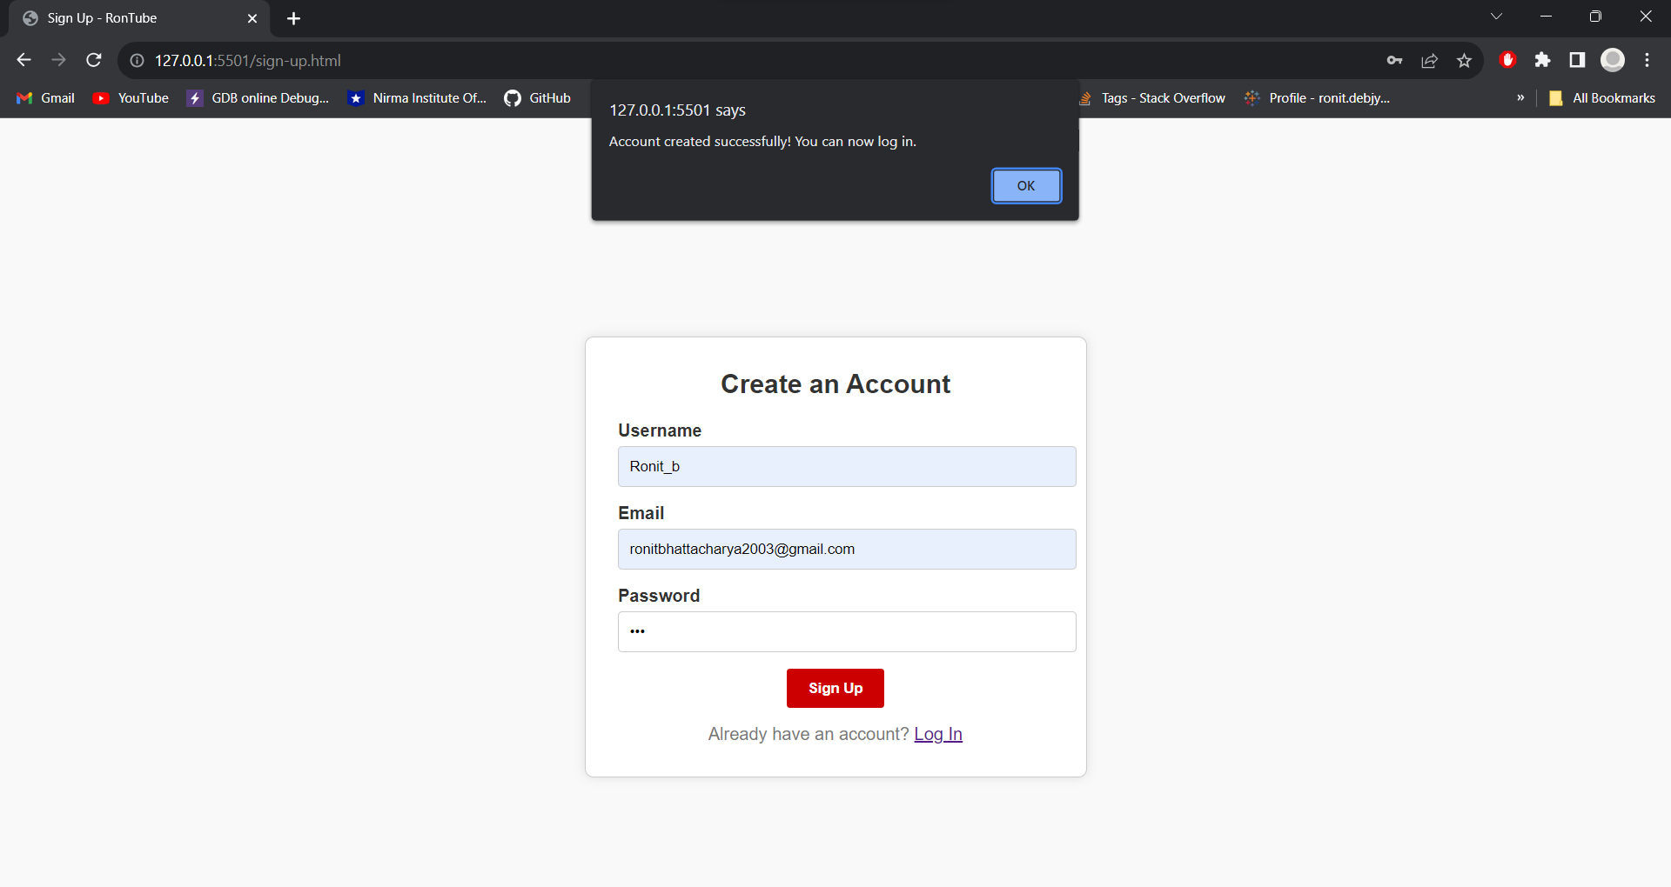

Login Successful

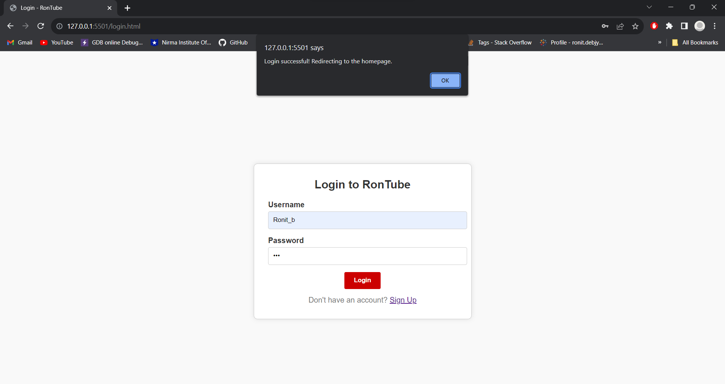

3) Home Page

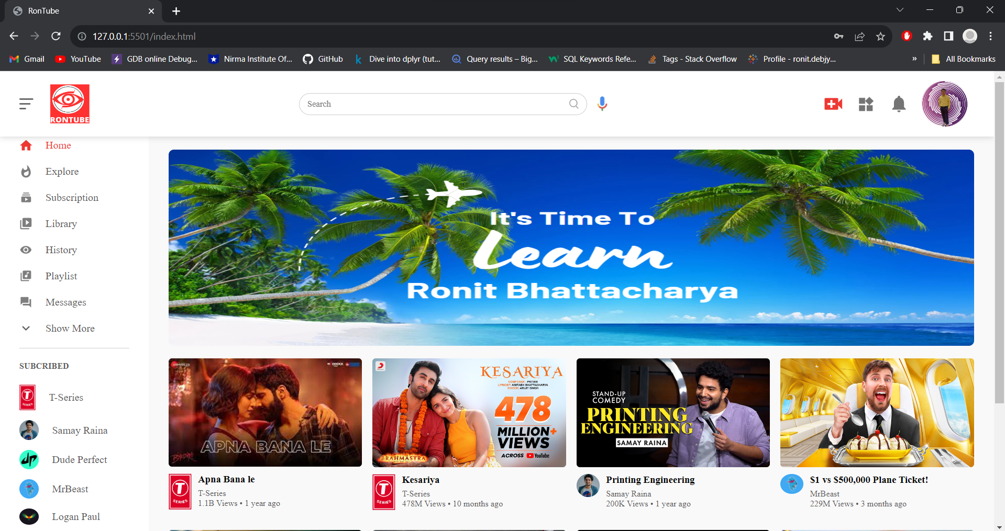

Side Bar Toggle

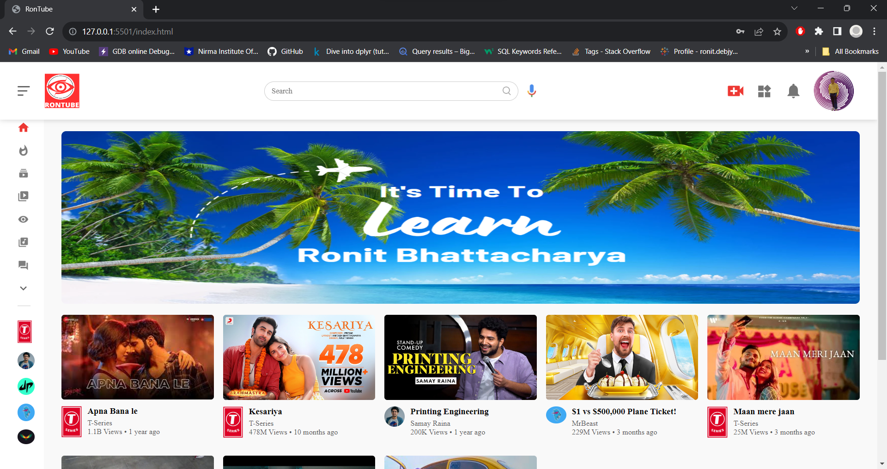

Responsive

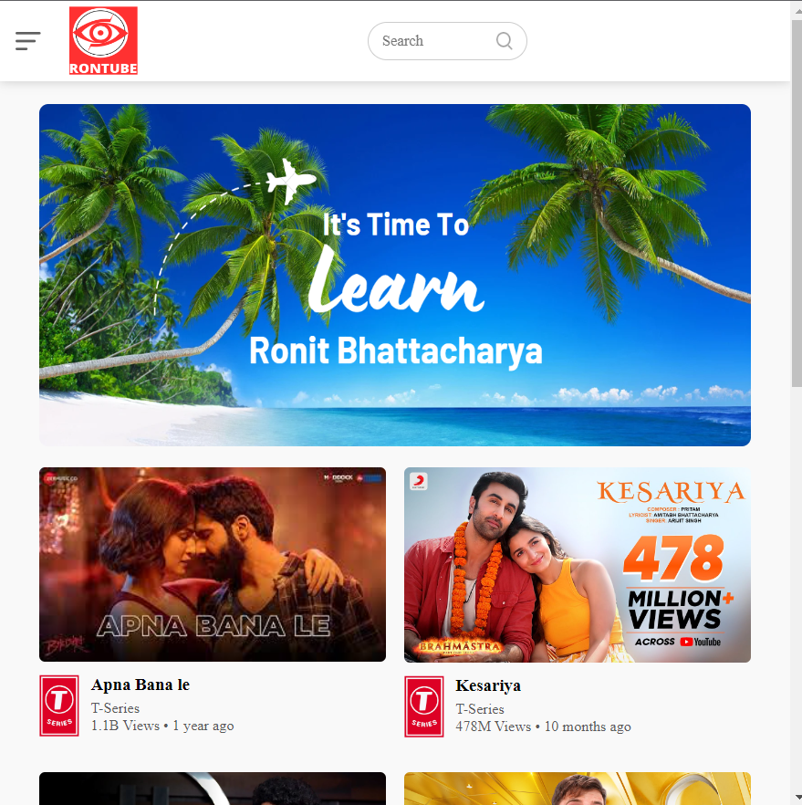

4) Video Playing Page – There are 8 different video playing pages

a)

